

Predictive

DNA REPORT



*DISCOVER YOUR TRUE POTENTIAL*

Barcode : john_doe

Name : JohnDoe

CustomerID :



**Powered by**

## Type o1 Report: Detailed Report

**DISCLAIMER**

OurrecommendationsinDNALifestylereportarebasedontheresultsofyourGeneticRiskAssessmentandotherrelatedinformation providedbyyou.Thisreportdoesnottakeintoaccountyourexistinghealthconditionoranymedicationthathavebeenprescribedtoyou. Thisreportbeingneitherasubstitutetomedicaltreatmentnorphysiciansvisitmakesitnecessaryforyoutoconsultyourphysicianbeforeadapting to itsrecommendations.

Anyassertionsorrecommendationsinthereportastoanexerciseregimeordiet,whetherspecificorgeneral,arebasedon thefollowingassumptions.

Thatyouareinagoodstateofhealthanddonothaveanymedicalproblemsthatyouareawareof;Thatyouhavenothadanyrecurringillnessinthepast12months;

Thatnomedicalpractitionerhaseveradvisedyounottoexercise;

Thatyouarenotonanyprescribedmedicationthatmayaffectyourabilitytoexercisesafelyoryourdiet;Thatyoudonothaveanyfoodallergies;and

That there is no other reason why you should not follow the assertions or recommendations in the report.

Ifyouhaveanyconcernsatanytimeaboutwhetherornottheseassumptionsarecorrectinyourparticularcircumstances,beforeacting,ornotacting,onanyoftheassertionsorrecommendations,youmustconsultamedicalpractitioner.

Becausescientificandmedicalinformationchangesovertime,andalsoaperson’sriskofanyparticularphenotype,conditionortraitisalsobasedonotherfactorslikeenvironment,diet,lifestyle,geneticvariants,yourriskassertionsandgeneticallytailoredpreventive recommendationsforoneormoreoftheconditionscontainedwithinthisreportmayalsochangeovertime.

Thepharmacogenomicpanelherereferstoyourgeneticpredispositiontothedrugsmentionedinthereport.Thisreportisforinvestigational purposeonly.Itistobeinterpretedbyaqualifiedandlicensedmedicalpractitioneronly.Itdoesnotconstitutemedicaladvice,diagnosis,or treatment.Theassayincludeslimitedsetofpolymorphismsandmaynotreportformutationsnotincludedinthetestpanel.Thisreportdoes nottakeintoaccountfactorslikedrug-druginteractions,drugfoodinteraction.Theseassaysarecarriedoutbytrainedindividualsanduse standard equipment and laboratory designed protocols. Licensed medical practitioners are trained and qualified to make therapeutic decisionspertainingtomedicationsandordosagebasedonpatientinformationandmedicalhistory,includingthepharmacogeneticreport.

Youareatalltimesresponsibleforanyactionsyoutake,ordonottake,asconsequenceoftheassertionsorrecommendationsinthereport,andyouwillnotholdDNALifestyleitsofficers,employeesandrepresentatives,harmlessagainstalllosses,costsandexpensesinthis regard,subjecttowhatissetoutbelow.

Tothefullestextentpermittedbylaw,neitherDNALifestylenoritsofficers,employeesorrepresentativeswillbeliableforanyclaim,proceedings,lossordamageofanykindarisingoutoforinconnectionwithacting,ornotacting,ontheassertionsorrecommendationsinthereport.Thisisacomprehensiveexclusionofliabilitythatappliestoalldamageandloss,including,compensatory,direct,indirectorconsequentialdamages,lossofdata,incomeorprofit,lossofordamagetopropertyandclaimsofthirdparties,howsoeverarising,whetherintort(includingnegligence),contractorotherwise.

Nothinginthisstatementisintendedtolimitanystatutoryrightsyoumayhaveasaconsumerorotherstatutoryrightswhichmaynotbe excluded,nortoexcludeorlimitourliabilitytoyoufordeathorpersonalinjuryresultingfromDNALifestylenegligenceorthatofitsofficers, employeesorotherrepresentatives.Nothinginthisstatementwilloperatetoexcludeorlimitliabilityforfraudorfraudulentactivities.

How to Read Your Report

**WHAT IS GENETICS?**

Humanaremadeupofcells

Cellsaremadeupof nucleus

Nucleusismadeupof chromosomes

ChromosomesaremadeupofDNA

DNA is made up of genes



  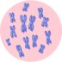 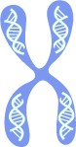  

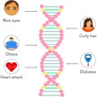

Changesinnucleotidesleadtogeneticvariations

Straighthair Curlyhair

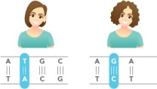Genes are coded by nucleotides

**SCOREINTERPRETATIONS**

|  |  |  |  |
| --- | --- | --- | --- |
|  | **SCORE** | **DEPICTION** | **INTERPRETATION** |
|  | 0-2 | Excellent / Protective | An'excellent/protective’scoreindicatesaveryfavorableresponseorabilityfor atrait |
|  | 2.1-4 | Good / Lower Risk | A'good/lowerrisk’scoreindicatesafavorableresponseorabilityforatrait |
|  | 4.1-6 | Typical | A 'typical’ score indicates a typical response or ability for a trait |
|  | 6.1-8 | Poor / SlightlyElevated | A'poor/slightlyelevated’scoreindicatesanunfavorableresponseorabilityfor atrait |
|  | 8.1-10 | VeryPoor/HighlyElevated | A'verypoor/highlyelevated’scoreindicatesaveryunfavorableresponseorabilityforatrait |

**GENERALGUIDELINES**

Geneticriskorpredispositiongiveninthereportisbasedonstatisticallyrelevantgenomicsresearchstudies,whichshouldnotbe taken as a diagnosis of any health conditionoroverallwellness.

Traitsinthereportarenotgeneticallyinterlinked;theirgeneticassociationsare independentofeachother.Therefore,everytrait score and interpretation areindependentof eachother.



ThisreportprovidesinformationTheinformationinthereportmayprovideanPleaseconsultwithyourdoctor,orother

about genetic predispositions onlyand may not indicate current conditions or characteristics.

understandingofone’sgeneticrisksand mayhelpinmakinginformeddecisions regardingone’swellnessandgoals.

qualifiedhealthcareprofessionalbefore makinganydietary,fitness,healthandwellness relatedchanges.

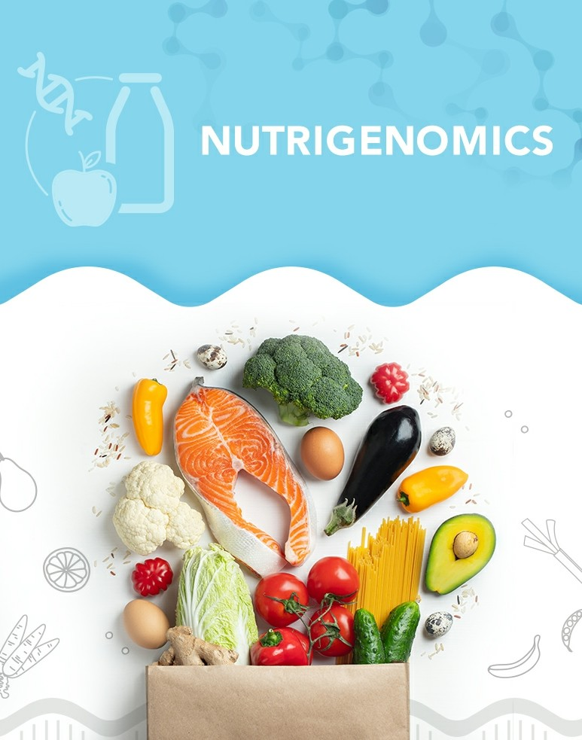

**Powefed by**



## Category Summary

**REGULATION OF EATING**

9.0

### □□□□□□

SatietyResponse

7.0

### □□□□□□

EmotionalEatingDependance

5.9

### □□□□□□

SnackingPattern



# SatietyResponse

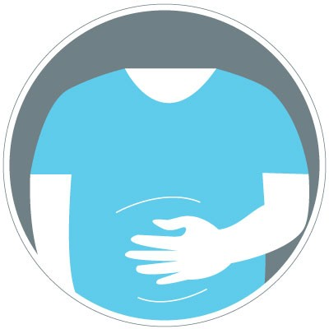

### WhatisSatietyResponse?

Satietymeansfeelingoffullnessorsuppressionofhungerforaperiodoftimeafterameal.Certaingeneticvariationscan influencetheabilitytofeelsatiatedafterconsumptionofameal,whichcanleadtoovereatingforindividualswithapoorsatietyresponse.Overeatingcanleadtoanexcessivecalorieintake,therebyincreasingtheriskofweightgain.

9.0

### □□□□□□

SatietyResponse

### Interpretation

Asperyourgenetics,yourSatietyResponseisverypoor.Peoplewithsuchagenotype tendtonotreachthesatietypointorafeelingoffullnessafterameal,whichcanleadtoexcessive calorieintake.

### Gene Table

Do's and Don'ts



**Emotional EatingDependance**



What is Emotional Eating Dependance ?

Emotionaleatingisaformofdisorderedeating,anditisdefinedasanincreaseinfoodintakeinresponsetoemotions. Somepeoplehaveastrongemotionalconnectionwithfood.Suchpeoplecanturntofoodforcomfortconsciouslyor subconsciously,whenfacingadifficultproblem,feelingstressed,orevenwhilefeelingbored.Emotionaleatingcanlead toexcessivecalorieintake,therebydamaginganyweightlossefforts.Sucharesponsetofoodcanbetriggeredduetovariations in certaingenes.

## 7.0

### □□□□□□

Emotional EatingDependance

### Interpretation

Asperyourgenotype,yourEmotionalEatingDependanceispoor.Peoplewithsuchagenotypearequitelikelytoindulgeinhighcalorieconsumptionduetoexcessive snackingduringanemotionaltrigger.

### GeneTable

Do's and Don'ts



**SnackingPattern**

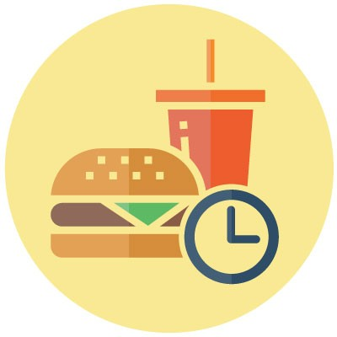

WhatisSnackingPattern?

Eatingbehaviorisacomplexinterplayofphysiological,psychological,social,andgeneticfactorsthatinfluencemeal timing,quantityoffoodintake,foodpreference,andfoodselection.Evenafterameal,someindividualstendtolookfor snacksormoremeals.Suchpeoplehaveanincreasedurgetosnackonfoodsthroughoutthedayeventhoughtheyfeelfull.Variationsincertaingenesareinvolvedinpoorsnackingpattern,resultinginovereating.

## 5.9

### □□□□□□

Snacking Pattern

### Interpretation

Asperyourgenotype,yourSnackingPatternistypical.Peoplewithsuchageneticmakeuptendtosnackatproperintervalsbetweenmeals.

### Gene Table

Do's and Don'ts





Category Summary

**TASTE PERCEPTION**

8.0

□□□□□□

Sweet Taste Perception

6.6

### □□□□□□

Fatty Food Preference

5.5

### □□□□□□

Bitter Taste Perception



# Sweet Taste Perception

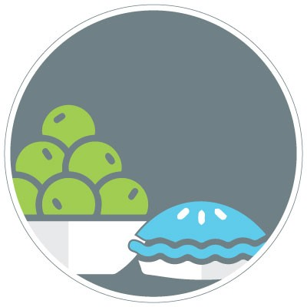

### What is Sweet Taste Perception ?

Sweettasteperceptionistheabilityofourtastebudstosensesweetfoods.Tasteperceptionexplainstheindividualfoodpreferencesandtheimpactofeatingbehaviorandnutritionalintake.Generally,thelesssensitiveonesarelikelyto consumemoreofthatfoodandtendtoovereat.Tastebudsforsweettasteperceptionareusuallyfoundatthebackof thetongueandtheroofofthemouth.Geneticvariationsinthegenesencodingtastereceptorsinfluencetheinter-individualdifferencesobservedinsweettasteperception.Peoplewithcertainvariantsarepoorsweettasteperceivers,andthereforetendtoconsumesugarsinhigheramounts.

8.0

### □□□□□□

Sweet Taste Perception

### Interpretation

Asperyourgenotype,yourSweetTastePerceptionispoor.Peoplewithsuchagenetic profilehaveaslightlylowersensitivitytowardssweetfoods,andhencemightbeunable tosatisfytheirsweetcravingseasily.Therefore,theymayindulgeinhigheramountsofsugaryfoods,resultinginintakeofemptycalories.

### Gene Table

Do's and Don'ts



**Fatty FoodPreference**

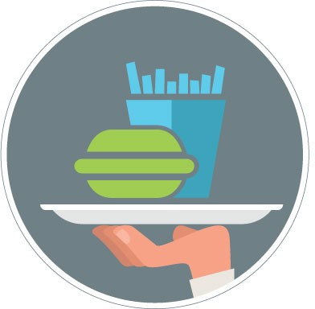

WhatisFattyFoodPre1erence?

Fattyfoodpreferencetellsusaboutourtaste-basedpreferenceforfoodsrichinfats,suchasdeepfriedfoods,nuts,cheese,andredmeats.Howanindividualperceivesthetasteoffoodsdictatestheindividualfoodpreferences,eatingbehavior,andnutritionalintake.Preferenceforfattyfoodsisgovernedbycertaingeneticvariationswhichcanlargelyinfluenceourfattyfoodintake.

## 6.6

### □□□□□□

Fatty Food Preference

### Interpretation

YourgenotypeforFattyFoodPreferenceispoor.Peoplewithsuchageneticprofilehaveahigherpreferenceforfattyfoods,whichmaypredisposethemtodeveloplifestyle diseases.

### Gene Table

Do's and Don'ts



**Bitter TastePerception**



What is Bitter Taste Perception ?

Bittertasteperceptionistheabilityofourtastebudstosensebitterfoods.Tasteperceptionexplainstheindividualfood preferencesandtheimpactofeatingbehaviorandnutritionalintake.Generally,thelesssensitiveonesaremorelikelytoconsumethatfoodandtendtoovereat.Lowerperceptionofbittertasteisgenerallyassociatedwithincreased consumptionofbitterfoods,whichcouldpossiblyleadtotoxicityinthebodyunderadverseconditions.Genetic variationsinthegenesencodingtastereceptorsareresponsiblefordifferencesinbittertasteperception.

## 5.5

### □□□□□□

Bitter TastePerception

### Interpretation

Asperyourgenotype,yourBitterTastePerceptionistypical.Peoplewithsuchagenetic profiletendtoperceivebittertastingfoodsasneitherextremelybitternorlessbitter.

### Gene Table

Do's and Don'ts





Category Summary

**MACRONUTRIENT REQUIREMENTS**

|  |  |  |
| --- | --- | --- |
| 6.8 | 7.1 | 5.5 |
| □□□□□□ | □□□□□□ | □□□□□□ |
| Response to Saturated Fats | Response to Monounsaturated Fats | Response to Carbohydrates |
| 6.2 | 2.0 | 2.0 |
| □□□□□□ | □□□□□□ | □□□□□□ |
| Response to Polyunsaturated Fats | Response to Protein | Response toFiber |

**Response To SaturatedFats**

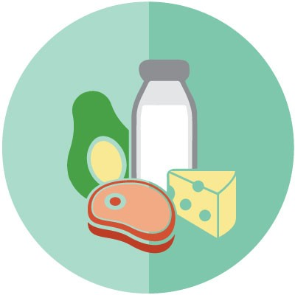

What is Response to Saturated Fats ?

Saturatedfatsareaclassofmacronutrientswhichareusedforenergygenerationbythebody.Saturatedfatsarefound inbutter,ghee,margarine,andinanimalfats.Theydifferfromothertypesoffatswithrespecttothenumberofdoublebondsintheirbackbone,withsaturatedfatshavingnone.Theytendtohavehighermeltingpointscomparedtounsaturated fats, which are generally liquid at room temperature. Saturated fats, when consumed in higher amountscomparedtootherfatsareknowntoincreaseLDLcholesterol,whichleadstodepositionofplaquesalongthewallsof thebloodvessels,causingnarrowingofbloodvessels.Thisdirectlyleadstoanincreaseintheriskofdeveloping cardiovasculardiseases.Geneticvariationscaninfluencehowthebodyrespondstosaturatedfatintake,intermsof developingabnormallipidprofilesandobesity.

## 6.8

### □□□□□□

ResponsetoSaturatedFats

### Interpretation

Asperyourgenotype,yourSaturatedFatResponseispoor.Peoplewithsuchagenotype tendtohaveaslightlyelevatedriskofbeingobeseorofhavingabnormallipidlevelspostconsumption of saturated fats, which in turn elevates the risk of adverse health conditionssuchasstrokeorcardiovasculardiseases.

### Gene Table

Do's and Don'ts



**Response To MonounsaturatedFats**

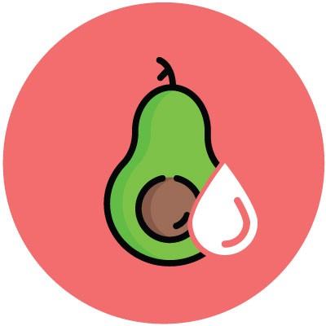

What is Response to Monounsaturated Fats ?

Monounsaturatedfattyacids(MUFA)areatypeoffatwhichcontainonedoublebondintheirbackbone.Thesefatsare usuallyliquidatroomtemperature.Monounsaturatedfatsalsoplayacriticalroleinregulatingthebody’simmunefunction.Eatingmonounsaturatedfatsinsteadofsaturatedfatsandtransfatscanlowercholesterollevelsandreduce theriskofheartdiseaseandstroke.MonounsaturatedfatsarealsohighinvitaminE,anantioxidantvitaminthatkeeps thebodyhealthybyprotectingcellsfromdamage.Foodslikeavocados,peanutbutter,nuts,seeds,oliveoil,peanutoil, canolaoil,sesameoil,andsunfloweroilareparticularlyhighinmonounsaturatedfats.GeneticvariationscaninfluencethedegreeofhealthbenefitsobservedwithMUFAintake.

## 7.1

### □□□□□□

Response toMonounsaturated Fats

### Interpretation

Asperyourgenotype,yourMonounsaturatedFattyAcid(MUFA)Responseispoor.PeoplewithsuchagenotypetendtobenefitlessfromMUFArichdietsascomparedtothe typicalpopulation.

### Gene Table

Do's and Don'ts



**Response To Carbohydrates**



What is Response to Carbohydrates ?

Carbohydratesareimportantmacronutrientsandtheprimarysourceofenergyandcaloriesforthebody.Carbohydrates are primarily divided into simple carbohydrate and complex carbohydrate groups. Simple carbohydrates are quickly brokendownandabsorbedbythebody,whichleadstoaspikeinthebloodsugarlevelsandinsulinsecretion.Increased consumptionofsimplecarbohydratessuchasrefinedflour,tablesugar,syrups,andfruitdrinkscouldincreasetheriskof developingdiabetesandobesity.Complexcarbohydrates,duetotheircomplexstructure,cannotbequicklybrokendown, causingslowandsustainedreleaseofsugarandinsulinintothebloodstream.Complexcarbohydratesourcesinclude oats,quinoa,brownrice,barley,andlegumes.Geneticvariationscaninfluencetheriskofdevelopinginsulinresistanceandobesityinresponsetocarbohydrateconsumption.

## 5.5

### □□□□□□

ResponsetoCarbohydrates

### Interpretation

Asperyourgenotype,yourCarbohydrateResponseistypical.Peoplewithsuchagenetic profiletendtometabolizecarbohydratesinatypicalmanner,therebynotaffectingtheir riskofdevelopinginsulinresistanceorobesityinresponsetocarbohydrateconsumption.

### Gene Table

Do's and Don'ts



**Response To PolyunsaturatedFats**



What is Response to Polyunsaturated Fats ?

PolyunsaturatedFattyAcids(PUFA)areatypeoffatwhichcontainmorethanonedoublebondintheirbackbone.PUFArichsourcesincludeoliveoil,soybeanoil,cornoil,andsunfloweroil.Othersourcesincludeseedssuchaswalnutsand flaxseeds.PUFAsatroomtemperaturesareliquids.PUFAscanhelpreduceLDLcholesterollevelsinthebloodwhichcan subsequentlylowertheriskofheartdiseaseandstroke.OilsrichinpolyunsaturatedfatsalsocontributevitaminE,anantioxidantvitaminthatkeepsthebodyhealthybyprotectingcellsfromdamage.TherearetwomaintypesofPUFA,omega3andomega6fattyacids.Omega3PUFAsareanti-inflammatoryandfoundinfattyfish,shellfish,liver,andin someseedslikeflaxseed.Omega6richfoodsarepredominantlypresentinanimalfats.Theidealratioofomega6to omega3isaround2:1to4:1,butmoderndietscontainratiosrangingfrom15:1toeven25:1,whichleadstoamuchincreaseddietaryneedforomega3intakeformostindividuals.Geneticvariationscaninfluencethedietaryrequirementforomega3PUFAintake.

## 6.2

### □□□□□□

Response toPolyunsaturated Fats

### Interpretation

Asperyourgenotype,yourPolyunsaturatedFattyAcid(PUFA)Responseispoor.Peoplewithsuchagenotypeusuallyshowadiminishedresponsetotheusualomega3PUFAintakeintermsofhealthbenefits,therebyleadingtoanincreaseddietaryrequirementforomega 3PUFA.

### Gene Table

Do's and Don'ts



**Response To Protein**



What is Response to Protein ?

Proteinisanessentialmacronutrientrequiredbythebodyforgrowthandmaintenance.Itactsasabuildingblockforallthecellsinthebodyandcanalsoserveasafuelsource.Whenbrokendownintoaminoacids,theyareusedas precursorstoseveralothermoleculesessentialforlife.Aprotein-richdietboostsmetabolismandreducesappetite. Therefore,consumptionofproteinsinvokesafeelingoffullness,decreasestotalcalorieconsumption,andreducesappetiteovertime,whichaidsinfatlossandweightmaintenance.Dietarysourcesofproteinincludebothanimalsand plantproteins,whichincludemeats,dairyproducts,fish,eggs,grains,legumes,andnuts.Geneticvariationscanleadtoalteredresponsetoincreasedproteinconsumptionintermsofmaintaininglostweight.

## 2.0

### □□□□□□

Response toProtein

### Interpretation

Accordingtoyourgenotype,yourProteinResponseisexcellent.Peoplewithsuchagenotypetendtoeasilymaintainbodyweightonadequateproteiningestion.Increasing proteinintakealongwithsuitableweighttrainingwouldhelpachieveoptimummusclemass andweight.

### Gene Table

Do's and Don'ts



**Response To Fiber**

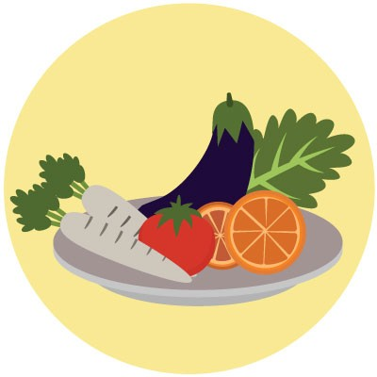

What is Response to Fiber ?

Dietaryfiberisatypeofcarbohydratethatcannotbedigestedbythebody.Theprimaryroleofdietaryfiberisinbowelfunction.Dietaryfiber,particularlyinsolublefiber,helpspreventconstipationbyincreasingstoolweightanddecreasing thetimeoftransitofstoolsinthegut.Italsohelpsinloweringtherisksofheartdiseaseanddiabetes.Fiberbasedfoods retainwaterintheintestinewhichhelpstofeelfuller,therebykeepingexcessivecalorieintakeincheck,whichreduces theriskofdevelopingobesity.Itiscommonlyfoundinfruits,vegetable,pulses,andwholegrains.Geneticvariationscaninfluencetheextentofbenefitthatincreasedfiberintakecanhaveonkeepingweightincheck.

## 2.0

### □□□□□□

ResponsetoFiber

### Interpretation

Asperyourgenotype,yourFiberResponseisexcellent.Peoplewithsuchagenotypeusuallyshowgreaterbenefitsintermsoffatlosswithincreasedfiberintake.

### Gene Table

Do's and Don'ts





Category Summary

**WEIGHT MANAGEMENTAND MAINTENANCE**

6.5

□□□□□□

Ability to Maintain Weight Loss

# Ability To Maintain Weight Loss



### What is Ability to Maintain Weight Loss ?

Whilelosingweightisdificultformanypeople,itisequallychallengingtokeeptheweightoff.Asignificantnumberofpeoplewholosealargeamountofweighttendtoregainit1to3yearslater.Certaingeneticvariationscaninfluencethe abilitytomaintainbodyweightpostweightloss.Thisincreasestheimportanceoffollowingahealthynutritionplanand exerciseregimentomaintaintheweightlossforthosepeoplewhoareatahighergeneticriskforregaininglostweight.

6.5

### □□□□□□

AbilitytoMaintainWeightLoss

### Interpretation

Asperyourgenotype,yourAbilitytoMaintainWeightLossispoor.Peoplewithsucha genotypetendtobeunabletomaintaintheirweightpostaweightlossintervention.

### Gene Table

Do's and Don'ts





Category Summary

**MICRONUTRIENT REQUIREMENTS**

|  |  |  |
| --- | --- | --- |
| 9.0 | 9.0 | 7.6 |
| □□□□□□ | □□□□□□ | □□□□□□ |
| Phosphate Metabolism | Calcium Metabolism | Vitamin A Metabolism |
| 7.2 | 8.0 | 7.0 |
| □□□□□□ | □□□□□□ | □□□□□□ |
| Vitamin E Metabolism | Vitamin C Metabolism | Vitamin B6 Metabolism |
| 6.0 | 6.9 | 5.0 |
| □□□□□□ | □□□□□□ | □□□□□□ |
| Vitamin D Metabolism | Iron Metabolism | Vitamin B9 Metabolism |
| 5.3 | 5.3 | 2.0 |
| □□□□□□ | □□□□□□ | □□□□□□ |
| Vitamin B12 Metabolism | Antioxidant Metabolism | Magnesium Metabolism |

**Phosphate Metabolism**

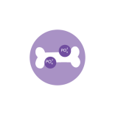

What is Phosphate Metabolism ?

Phosphateisanessentialmineralthatisnecessaryfortheformationofbonesandteeth.Inthebody,almostallofthe phosphorusiscombinedwithoxygen,formingphosphate.Phosphateisalsousedasabuildingblockforseveralimportantsubstancesincludingthoseusedbythecellforenergygeneration,makingcellmembranes,andmakingDNA. Dietarysourcesofphosphateincludemilk,meatproducts,seafish(salmon,mackerel,andsardines),seeds(pumpkinand sunflowerseeds),legumes,eggs,andoatmeal.Geneticvariationscaninfluenceserumphosphatelevels,therebyleadingto altered dietaryrequirement.

## 9.0

### □□□□□□

Phosphate Metabolism

### Interpretation

Asperyourgenotype,yourPhosphateMetabolismisverypoor.Peoplewithsuchagenotypetendtobeinefficientatphosphatemetabolism,therebyleadingtoanincreaseddietaryrequirement.

### Gene TableDo'sandDon'ts



What is Calcium Metabolism ?

Calciumisthemostabundantmineralinthebody,morethan90%ofwhichispresentinthebonesandteeth.Calciumis alsoimportantforproperfunctioningofthethyroidgland.Calciumisabsorbedbythebodyintheformofphosphatesaltsanditiscrucialfortheregulationofmusclecontractionandheartfunctioning.Calciumlevelsinthebloodarealsoimportantintheproductionofclottingfactorsandfornerveimpulsetransmission.Givenitsmultitudeoffunctionsinthehumanbody,deficiencyofcalciumcanleadtoproblemssuchasosteoporosis,osteopenia,andmusclecramps.Excessiveintakeofcalciumcancauseconstipation,increasedthirstorurination,nausea,vomiting,andkidneystones. Foods rich in calcium include all dairy products, almonds, broccoli, cabbage, soybeans, tofu, salmons, and sardines.Geneticvariationscanleadtoabnormalcalciumabsorptioninthebody.

## 9.0

### □□□□□□

Calcium Metabolism

### Interpretation

Asperyourgenotype,yourCalciumMetabolismisverypoor.Peoplewithsuchagenotypetendtohaveanelevatedriskofdevelopinghighserumcalciumlevels.

### Gene Table

Do's and Don'ts



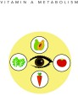

What is Vitamin A Metabolism ?

VitaminAisagroupofnutritionalorganiccompoundswhichareofprimaryimportanceintheprocessofvision.Italsoplaysanimportantroleintheimmunefunctionofthebodyandinmaintainingskinhealth.Animalsourceslikeorgan meat,fish,andmilkproductsprovidevitaminAintheformofretinolorretinoicacid,whileplantsourceslikecarrots,sweetpotatoes,spinach,kale,andcantaloupesprovidetheprecursorofvitaminAintheformofcarotenes,whichare convertedintoretinolinsidethebody.SomesymptomsrelatedtovitaminAdeficiencyincludenightblindness,acne,or dryskin.ExcessvitaminAinthebodycouldleadtoabdominalpain,musclepain,nausea,vomiting,anddiarrhea.Geneticvariations can affect the process of beta-carotene conversion to retinol, thereby influencing dietary vitamin A requirement.

## 7.6

### □□□□□□

VitaminAMetabolism

### Interpretation

Asperyourgenotype,yourVitaminAMetabolismispoor.Peoplewithsuchagenotype tendtohaveareducedabilitytometabolizevitaminA,therebyincreasingtheirriskofvitamin Adeficiency.

### Gene TableDo'sandDon'ts



**Vitamin E Metabolism**



What is Vitamin E Metabolism ?

VitaminE,alsoknownastocopherolsareaclassoffat-solublevitamins.PrimaryroleofvitaminEinthebodyisasan antioxidant,toneutralizethefreeradicalsproducedinthebody,therebypreventingcellulardamage.Itisalsoan importantcomponentoftheimmunesystem.VitaminEdeficiencyhasbeenknowntocausecognitivedeclineand neuromuscularproblems.VitaminEispossiblyunsafeinexcessandmayleadtonausea,diarrhea,stomachcramps,headache,andbleeding-relatedproblems.SourcesofvitaminEincludevegetableoils,nuts,salmon,crayfish,soybean,spinach,broccoli,andalmonds.GeneticvariationscaninfluencetheabsorptionofvitaminEinthebody.

## 7.2

### □□□□□□

Vitamin EMetabolism

### Interpretation

Asperyourgenotype,yourVitaminEMetabolismispoor.Peoplewithsuchagenotype tendtohavelowerplasmalevelsofvitaminEduetoitsinefficientabsorption.Therefore,theyareatanelevatedriskforvitaminEdeficiency.

### Gene Table

Do's and Don'ts



**Vitamin C Metabolism**



What is Vitamin C Metabolism ?

VitaminC,alsoknownasascorbicacid,isanessentialwater-solublevitamininvolvedintherepairoftissuesandtheenzymaticproductionofcertainneurotransmitters.Italsoplaysanimportantroleintheimmunesystem,functioningasanantioxidant.VitaminCdeficiencyhasbeenknowntocausescurvy(bleedingofgums),skinrashes,andimpairedwoundhealing.However,excessintakecouldcausegastrointestinalproblems,headache,andtroublesleeping.Sources richinascorbicacidincludecitrusfruitssuchasorangesandgrapefruit,kiwi,mango,andpapaya.GeneticvariationscaninfluencetheabsorptionofvitaminCinthebody.

## 8.0

### □□□□□□

VitaminCMetabolism

### Interpretation

Asperyourgenotype,yourVitaminCMetabolismispoor.Peoplewithsuchagenotype tendtohaveareducedabilitytoabsorbvitaminC.Therefore,theyareatanelevatedriskfor vitamin Cdeficiency.

### Gene TableDo'sandDon'ts



What is Vitamin B6 Metabolism ?

VitaminB6isapartofthevitaminBgroupofessentialnutrients.OurbodiesuseBvitaminstoconvertthefoodweeatintotheenergyweneedtofunction.Itplaysacrucialroleincarbohydrate,lipid,andaminoacidmetabolism.Deficiencyof vitaminB6isassociatedwithanemia,dermatitis,andweakenedimmunefunctionofthebody.Whenpresentinexcess,it hasbeenshowntocauseneurologicaldisorders.VitaminB6sourcesincludechicken,eggs,chickpeas,bananas,sweet potatoes,pistachios,andspinach.GeneticvariationscanaltertheabsorptionofvitaminB6,therebyinfluencingtheriskofvitamin B6deficiency.

## 7.0

### □□□□□□

Vitamin B6Metabolism

### Interpretation

Asperyourgenotype,yourVitaminB6Metabolismispoor.Peoplewithsuchagenotype tendtohavelowerplasmalevelsofvitaminB6duetoitsinefficientabsorption.Therefore,theyareatanelevatedriskforvitaminB6deficiency.

### Gene Table

Do's and Don'ts



**Vitamin D Metabolism**



What is Vitamin D Metabolism ?

VitaminDisafat-solublevitaminwhichissynthesizeduponexposureofskintosunlight.VitaminDplaysanimportant roleinregulatingcalciumlevelsintheblood,therebyplayinganimportantroleinmaintenanceofbonehealth.VitaminD deficiencyhasbeenassociatedwithrickets(boneandmuscleweakness).Italsoresultsincognitiveimpairmentinolderpeople.ExcessvitaminDinthebodyisassociatedwithelevatedcalciumlevelsintheblood,whichintheshorttermcouldleadtonausea,vomiting,andpoorappetite.FoodsourcesforvitaminDincludetuna,salmon,eggyolks,cheese, andspinach.However,foodsourcescontainonlyaverysmallpercentageofdailyvitaminDrequirement,therebymakingsunlighttheprimarysourceforvitaminD.GeneticvariationscaninfluencethemetabolismofvitaminD,thereby influencingtheriskofdevelopingvitaminDdeficiency.

## 6.0

### □□□□□□

VitaminDMetabolism

### Interpretation

Asperyourgenotype,yourVitaminDMetabolismistypical.PeoplewithsuchagenotypetendtohaveatypicalefficiencyformetabolisingvitaminD.

### Gene Table

Do's and Don'ts



**Iron Metabolism**



What is Iron Metabolism ?

Ironisanessentialelementrequiredinthebodyfortheproductionofredbloodcells.About70%ofthebody’sironstores arefoundintheredbloodcells.Itisessentialfortheformationofhemoglobinandtransportofoxygentothecellsinthebody.Ironisalsoinvolvedinimmune-systemrelatedfunctionsandisacriticalnutrientforenergymetabolismpathway.Deficiencyofironcanleadtofatigue,weakness,paleskin,headache,anddizziness,whileexcessironintakeistoxictothebody.Dietarysourcesofironincludechicken,tofu,redmeats,broccoli,brusselsprouts,legumes,andspinach. Geneticsvariationscanaffectironmetabolismandtherebyinfluencetheabilitytoabsorbironfromthediet.

## 6.9

### □□□□□□

Iron Metabolism

### Interpretation

Asperyourgenotype,yourIronMetabolismispoor.Peoplewithsuchagenotypeare usuallyatanelevatedriskofdevelopingirondeficiencyduetoitsinefficientabsorptionandtransport.

### Gene Table

Do's and Don'ts



**Vitamin B9 Metabolism**



What is Vitamin B9 Metabolism ?

VitaminB9,morecommonlyknownasfolate(naturally-occurringformofB9)orfolicacid(asyntheticform),isawater-solublevitaminthatisapartoftheBvitaminfamily.VitaminB9,whenconvertedtoitsactiveform,playsanimportant roleinDNAsynthesisandcelldivision,redbloodcellproduction,andclearanceofhomocysteine,allofwhichare affected in cases of impaired metabolism of vitamin B9. An excess accumulation of homocysteine can induceinflammation,damagebloodvessels,increasebloodpressure,andcauseadisturbanceinhearthealth.However,excess vitaminB9intakehasbeenknowntocausestomachproblems,troublesleeping,andadverseskinreactions.SourcesrichinvitaminB9includeeggyolks,beefliver,tuna,legumes,asparagus,andbeetroots.Variationsincertaingenescan influencethemetabolismofvitaminB9.

## 5.0

### □□□□□□

Vitamin B9Metabolism

### Interpretation

Asperyourgenotype,yourVitaminB9Metabolismistypical.PeoplewithsuchagenotypetendtohaveatypicalefficiencyforconvertingdietaryvitaminB9intoitsactiveform.

### Gene TableDo'sandDon'ts



**Vitamin B12 Metabolism**

What is Vitamin B12 Metabolism ?

VitaminB12,orcobalamin,isawater-solublevitamininvolvedinmanymetabolismpathwaysinourbody.Itisparticularlyimportantinthenervoussystemfunctioningandsynthesisofmyelin.ItalsoplaysanimportantroleinredbloodcellformationandproductionofDNA.Alongwithfolateandribouavin,italsohelpsineliminatinghomocysteinefromthecell. DeficiencyofvitaminB12hasknowntocauseimpairednervoussystemfunctioning,lethargy,andfatigue.VitaminB12 sourcesincludechicken,meat,tofu,eggs,salmon,dairyproducts,andalmondmilk.Geneticvariationscanaffectitsabsorptionfromfood,therebyinfluencingtheriskofvitaminB12deficiency.

## 5.3

### □□□□□□

VitaminB12Metabolism

### Interpretation

Asperyourgenotype,yourVitaminB12Metabolismistypical.PeoplewithsuchagenotypetendtohaveatypicalefficiencyforvitaminB12absorption.

### Gene Table

Do's and Don'ts



**Antioxidant Metabolism**



What is Antioxidant Metabolism ?

Antioxidantsarecompoundsthatinhibittheoxidationprocessinthebody.Certainprocessescanleadtotheformationof oxidativespeciesinthebody,whichcandamagethecellsandDNA,leadingtoimpairedcellularfunctions.Theabilityof antioxidantstodestroyoxidativespeciesprotectsthestructuralintegrityofcellsandtissues.Antioxidantsalsofunctioninstrengtheningtheimmuneresponseofthebody.TheyhavealsobeenknowntoreducetheriskofcancerandneurodegenerativediseasessuchasAlzheimer’sandParkinson’s.Sourcesrichinantioxidantsincludedarkchocolate, spinach,greentea,andblueberries.Geneticvariationscanleadtoalteredfunctioningofthebody’sinnateantioxidantdefencesystem,therebyinfluencingthedietaryrequirementforantioxidants.

## 5.3

### □□□□□□

Antioxidant Metabolism

### Interpretation

Asperyourgenotype,yourAntioxidantMetabolismistypical.Peoplewithsuchagenotypetendtohaveatypicalantioxidantdefencesystemefficiency.

### Gene Table

Do's and Don'ts



**Magnesium Metabolism**



What is Magnesium Metabolism ?

Magnesiumisthefourthmostabundantmineralinthebody.Ithelpsinmaintainingnormalnerveandmusclefunction, supportsahealthyimmunesystem,keepstheheartbeatsteady,andhelpsbonesremainstrong.Magnesiumalsoworks withcalciumforregulationofmusclecontraction.Deficiencyofmagnesiumhasbeenassociatedwithimpropernerve impulses, thereby resulting in poor coordination, muscle spasms, tremors, and loss of appetite. Meanwhile, excess magnesiumintakehasbeenassociatedwithirregularheartbeats,lowbloodpressure,andslowedbreathing.Sourcesrich inmagnesiumincludesalmon,mackerel,tuna,spinach,kale,nuts,anddarkchocolate.Geneticvariationscaninfluencetheabsorptionofmagnesium,therebyaffectingitsserumlevels.

## 2.0

### □□□□□□

Magnesium Metabolism

### Interpretation

Asperyourgenotype,yourMagnesiumMetabolismisexcellent.Peoplewithsuchagenotypetendtobeveryefficientatmagnesiummetabolism.

### Gene Table

Do's and Don'ts





Category Summary

**FOOD INTOLERANCES ANDSENSITIVITIES**

|  |  |  |
| --- | --- | --- |
| 8.7 | 9.0 | 6.5 |
| □□□□□□ | □□□□□□ | □□□□□□ |
| Salt Metabolism | Lactose Intolerance | Gluten Intolerance |
| 3.6  □□□□□□ |  |  |
| Caffeine Metabolism |  |  |

**Salt Metabolism**



What is Salt Metabolism ?

Tablesaltisamineralcomposedprimarilyofsodiumchloride.Sodiumisanimportantelectrolyteandanessentialnutrientforhumanhealth,whoseroleinthebodyisprimarilyasanelectrolyteandmaintainingfluidbalance.Sodium enablesthetransmissionofnerveimpulsesaroundthebody,regulatingtheelectricalchargesmovinginandoutofthe cells.Thepresenceofsodiumionsisessentialforthecontractionofmusclesincludingthemostimportantmuscle,theheart.Excesssodiuminthebodyhasmanysideeffectssuchashypertension,fluidretention,swelling,andedema.Severesweating,vomiting,anddiarrheaarealsomarkedlyassociatedwithincreasedsodiumlevels.Thefoodsources richinsodiumarecuredmeats,saltedfish,cheese,andcannedfoods.Geneticvariationscaninfluencehowanindividualrespondstosaltintake,therebyinfluencinghowmuchsaltcanbetoleratedintheirdiet.

## 8.7

### □□□□□□

Salt Metabolism

### Interpretation

Asperyourgenotype,yourSaltMetabolismisverypoor.Peoplewithsuchagenotypeare likelytorespondverypoorlytoincreasedsaltintake,andthereforeareadvisedtolimitconsumption.

### Gene Table

Do's and Don'ts



**Lactose Intolerance**



What is Lactose Intolerance ?

Lactose,commonlycalledmilksugar,isaformofcarbohydratepresentinmilkandotherdairyproducts.Itmakesdairy productstastemildlysweet.Thebodystartsmetabolizinglactoseintheintestineswiththehelpoflactase,anenzymeproducedandreleasedbythecellsthatlinethesmallintestine.Whenthebodydoesnotproduceenoughlactase enzyme,lactoseisfermentedbytheintestinalbacteria.Thisleadstoformationoflacticacidandvariousgasesinthestomach,causingsymptomsrelatedtolactoseintolerance.Symptomsoflactoseintolerancearebloating,gasformationinthestomach,anddiarrhea.Geneticvariationscaninfluenceanindividual'sriskofdevelopinglactoseintolerance.

## 9.0

### □□□□□□

Lactose Intolerance

### Interpretation

Asperyourgenotype,yourLactoseMetabolismisverypoor.Peoplewithsuchagenotype tendtohaveahighlyelevatedriskofdevelopinglactoseintolerance.Itisusuallyadvisedtosuchpeoplethattheyhavealimitedintakeofdairyproductsoravoiditaltogether.

### Gene Table

Do's and Don'ts



**Gluten Intolerance**



What is Gluten Intolerance ?

Glutenisaformofstorageproteinthatisstoredtogetherwithstarchintheseedsofvariouscerealssuchaswheat,barley,rye,andoats.Gluteninwheatisresponsibleforprovidingtheelasticityandmakingitriseduringbakingprocess.Glutenintoleranceischaracterizedbyadversereactionstogluten.Celiacdiseaseisthemostsevereformofglutenintolerance.Symptomsofglutenintoleranceuponconsumptionofgluten-containingproductsincludebloating,diarrhea, constipation,andabdominalpain.Celiacdiseasehasalsobeenassociatedwithotherdiseasessuchasdiabetes,thyroid disorders,andotherautoimmunediseases.Peopleintoleranttoglutencanconsumegluten-freecereals.Agluten-freedietisessentialformanagingsignsandsymptomsofceliacdiseaseandothermedicalconditionsassociatedwith gluten.Geneticvariationscaninfluenceanindividual’sriskofdevelopingceliacdisease.

## 6.5

### □□□□□□

GlutenIntolerance

### Interpretation

Asperyourgenotype,yourGlutenMetabolismispoor.Peoplewithsuchagenotypetend tohaveahighriskofdevelopingglutenintolerance.Ongluteningestion,theymayexhibit gastrointestinaldisturbanceslikeabdominalbloating,flatulence,cramps,anddiarrhea.

### Gene Table

Do's and Don'ts



**Caffeine Metabolism**



What is Ca11eine Metabolism ?

Caffeineisacentralnervoussystemstimulant,presentinbeveragessuchascoffee,tea,energydrinks,andaerateddrinkslikecola.Caffeineinvokesasenseofalertnessandwakefulnessuponconsumption.However,itcanalsoproduce amildformofdependence.Generally,upto400mgofcaffeineappearstobeasafedoseforadults,butgreatvariabilityisobservedintermsofhowmuchcaffeinecanbetoleratedbyanindividual,whichinturnisgovernedbygeneticvariations.Excesscaffeineconsumptioncancauseseveralsideeffectssuchasanxiety,insomnia,digestiveissues,highbloodpressure,andrapidheartrate.

## 3.6

### □□□□□□

Caffeine Metabolism

### Interpretation

Asperyourgenotype,yourCaffeineMetabolismisgood.Peoplewithsuchagenotypetendtobefastmetabolizersofcaffeineandthereforecantoleraterelativelyhigher amounts.

### Gene Table

Do's and Don'ts

